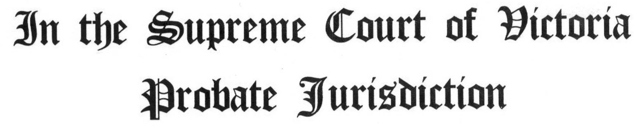

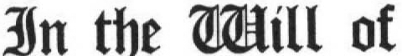 HENRY THEODORE CROLL late of 2 Flett Street Bunyip Victoria, Farmer deceased.

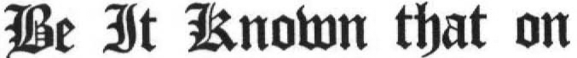 that on

the will (a true copy of which is annexed) of the abovenamed deceased who died on the 15th June 2003 was proved by LYNETTE CROLL of 2 Flett Street Bunyip Victoria, Farmer and TREVOR HENRY CROLL of 2 Flett Street Bunyip Victoria, Electrical Engineer the executors named in the Will of the deceased.

BY THE COURT –

REGISTRAR OF PROBATES
Issued to the applicants in person
LYNETTE CROLL AND
TREVOR HENRY CROLL
2 Flett Street
Bunyip Victoria 3815
Tel (03) 56295559

